**SOUTHERN CONSERVATION DISTRICT**

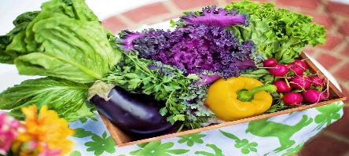

**4th Annual Women in Agriculture Workshop**

Date**: May 22, 2019**

Time: **9:30 a.m. to 3:00 p.m.**

Location: **Tamarack Conference Center**

**Workshop Topics:**

Essential oils and massage therapy – Anew YOU Massage & Spa, LLC

Growing shiitake mushrooms – WV Conservation Agency

WV forest edibles - WV Conservation Agency

Lunch

Healthy eating from our gardens – WVU Extension

Growing and preserving herbs – WVU Extension

Lunch will be provided by the Southern CD

* Registration is required. Please call 304-253-0261 no later than May 3 to be sure your registered.