**Wheatheart Post Driver for Bid**

**Purchased in 2008**

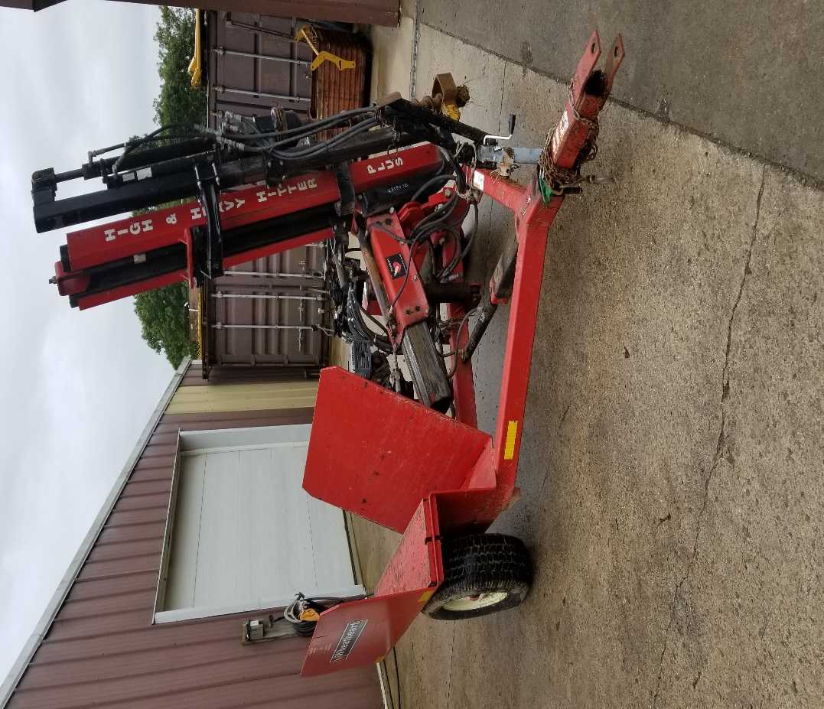

All interest parties should submit a **SEALED BID.** Bid should include full name, address, phone number of bidder and the amount of bid. **Monongahela CD reserves the right to reject any or all bids and reserves the right to withdraw the property at any time prior to the award.** Payment will be required prior to pick up within 10 business days of bid opening. Cashier’s and /or personal checks accepted with proper ID. No minimum bid, equipment as-is, no delivery must pick up.

**Sealed bids must be submitted to Monongahela CD by May 10, 2019 by 3:00 p.m.**

Submit sealed bids to:

Monongahela Conservation District

201 Scott Avenue

Morgantown, WV 26508

Call or email with questions: 304-296-0081 or mcd@wvca.us