Guyan Conservation District

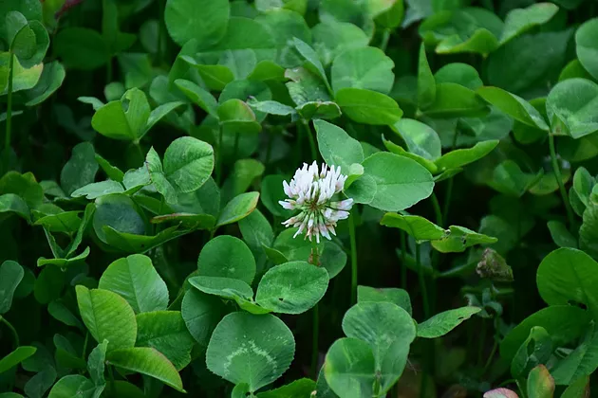

FY 20 FROST SEEDING SIGN UPS

Guyan Conservation District will be taking signups for the AgEP Frost Seeding practice. The Agriculture Enhancement Program provides cost share assistance for a variety of agricultural practices. To be eligible for frost seeding you must provide current soil sample results for each field and the soil pH must be above 6.0. To apply for the program, please stop by the GCD office to fill out an application.

Sign Ups will be held:

December 2, 2019- January 3, 2020

Please contact Guyan Conservation District for questions or more information.

304-528-5718