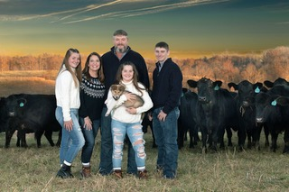

Meadows won West Area Conservation Farm Contest which consists of Western Conservation District (Jackson, Mason, and Putnam Counties) Northern Panhandle District, Upper Ohio District, Little Kanawha District, Elk District, Capitol District, and Guyan District. Jason Meadows will find out if he will receive the WV State Conservation Farm Award on October

The Meadows Cattle Farm located in Ripley, WV is owned and operated by Jason B Meadows. The 515-acre farming operation consists of Polled Registered Herefords, Registered Black Angus along with commercial cattle on the farm. His son Jace, which will be the third generation for this farm and Jason have taken several classes to learn more environmental friendly ways to enhance their farm including: Beef Quality Assurance, more economical ways on marketing & budgeting, soil management, cattle production, forage production and they also hosted a three day artificial insemination class.

The farm of 346 acres was purchased in 2008, and over the years Jason has added another 169 acres to the farm to make the 515 acres. The farmland had not been farmed for many years and was used for hunting only. Over the years, with a lot of hard work and many hours of labor, along with ap-plications of lime, fertilizer and cattle manure spread on the pastures have made it more productive. With the help of FSA, NRCS and Western Conservation District, the farm has improved pasture and hay land by increasing PH levels, and rotational grazing which has led to better quality live-stock production.

Jason was raised in Jackson County and said he was very happy to say that he is also raising his family in Jackson County. His parents from early on made both Jason and his brother aware of how important it is to volunteer in the community, church, and schools and know even small things matter. His wife, Sherry and Jason believe in this as well, Sherry is a Teacher at Henry J Kaiser and spends many hours volunteering in the community with 4-H, FFA, soccer, basketball, cheerleading, cross country and any other sport or activity that their children might participate in. Jason joined 4-H when he was nine years old and continued that along with FFA all through high school, their children are also 4-H and FFA members. Jason and Sherry have 3 children Jace, Zoie, and Jett. Jace is currently serving as Chaplain for the Ravenswood FFA Chapter. Jace also has his State FFA Degree and is working on his American FFA Degree.