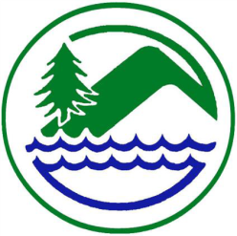
West Fork Conservation District

March 11th, 2026

USDA Service Center

Mount Clare, WV

09:00 A.M. Call to Order
Pledge of Allegiance
Welcome and Introductions
M Approval of Agenda
D/M Approval of Board Meeting minutes of February 11th, 2026, Board Meeting

D Cooperating Agencies Report
- NRCS, FSA, Forestry, WVU Extension Service, WVACD Exec. Dir.
Financial Reports
M District Bookkeeper General & CDO Funds Report/WVCA Restricted Funds Report
M Supervisor Per Diem & Travel
M Approval of Invoices & Payments
D/M

Unfinished Business

D/M AgEP Program
Payments:
Darrell Cunningham, IS $ 456.72
John L. Spiker, Lime, $ 1.600.00 (Calculation Error)
Richard Law, PDF, $ 2,643.74

Cancelations:
Ira Pritt, WS Canceled 3/4/2026

D/M Conservation Agreements: None currently

D/M OM&R Polk Creek & Salem Fork:
D/M Dam Inspection Reports:

Old Business:
D/M

New Business
D/M Plan of Work
D/M Administration Agreement/AGEP FY27

Correspondence - None Currently
Funding Request None Currently

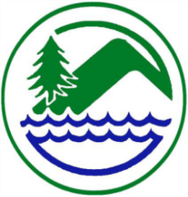
D/M Letters of Request: None Currently

D/M SSRP/EWP Project-
D/M Board Member, Associate Supervisor, and Committee Reports
D WVCA/District Employee Report
WVCA: Amanda Grady, Don Whetzel, Dee Horner
WFCD: Jennifer Metheny
D Public Comments
Set Date of Next Meeting
April 8th, 2026, At The USDA Service Center, Mt. Clare. 9:00 a.m.

Adjournment

Upcoming Meetings and Programs:
March 16th & 31st, 2026- Check Processing Dates

April 8,2026 USDA Service Center, Mt Clare, WV 9:00 AM
May13,2026, USDA Service Center, Mt. Clare, WV 9:00 AM
June 10,2026, USDA Service Center, Mt. Clare, WV 9:00 AM
July 8,2026, USDA Service Center, Mt. Clare, WV 9:00 AM
August 12,2026, USDA Service Center, Mt. Clare, WV 9:00 AM
September 9,2026, USDA Service Center, Mt. Clare, WW 9:00 AM
October 14,2026, USDA Service Center, Mt. Clare, WV 9:00 AM
November 11,2026, UDSA Service Center, Mt. Clare, WV 10:00 AM
December 9,2026, USDA Service Center, Mt. Clare, WV 10:00 AM

D – Discussion

M – Possible Motion

