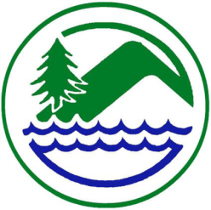
West Fork Conservation District

August 12th,2026
USDA Office Building
Mount Clare, WV

9:00 A.M. Call to Order
Pledge of Allegiance
Welcome and Introductions
M Approval of Agenda
D/M Approval of meeting Minutes for July 8th Board Meeting
D/M Approval of Special Board Meeting Minutes approval July 31,2026

D Cooperating Agencies Report
- NRCS, FSA, Forestry, WVU Extension Service, WVACD Exec. Dir.
Financial Reports
M District Bookkeeper General & CDO Funds Report/WVCA Restricted Funds Report
M Supervisor Per Diem & Travel
M Approval of Invoices & Payments

D/M AgEP Program:
FY 27 Applications Approvals:
Payments: None Currently
Cancelations: None Currently
Conservation Agreements: Non-Currently

D/M OM&R Polk Creek & Salem Fork
D/M Dam Inspection Reports

Old Business
D/M

New Business
D/M Carol Greene Nomination
D/M Member At Large Nomination
D/M Honorary Member Nomination
D/M Rookie Supervisor Nomination
D/M Grassland Farmer Nomination

D/M Correspondence - None Currently
D/M Funding Request- None currently
D/M Letters of Request – None Currently
D/M SSRP/EWP Project-
D/M Board Member, Associate Supervisor, and Committee Reports

D WVCA/District Employee Report
- WVCA – Don Whetzel, Amanda Grady, Dee Horner
- WFCD- Dee Horner
D Public Comments
Set Date of Next Meeting Wednesday September 9th, 2026- USDA Service Center- Mount Clare, WV 9:00 AM

Adjournment

Upcoming Meetings:
September 9th @ Mount Clare Office 9:00 AM

August 31st, 2026 - Check processing date

September 7th, 2026, ^{Labor} Day Office Closed

D – Discussion

M – Possible Motion

